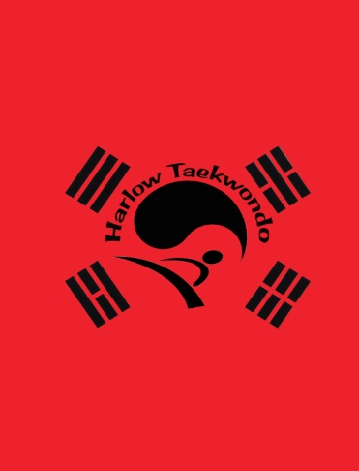
Red Tag Terminolgy
Red belt signifies danger cautioning the student to exercise control and warning the opponent to beware.

What is Korean for one step sparring? - Ilbo Matsoki
Why do we jump into x stance in Toi Gye? - to avoid a swung stick
Who are the founder members of the TAGB and what are their positions on the committee?
  - Mr Dave Oliver - Chairman
  - Mr Michael Dew - Vice Chairman
  - Mr Ron Sergiew - Treasurer
  - Mr Paul Donnelly -Liason Officer
  - Mr Kenny Walton -Team Coach
  - Mr Don Atkins - National Secretary
  - Mr Gianni Peros -Welsh Team Coach
  - Mr Brian Towndrow -Committee Member
Stances
- Close ready stance -Moa JunbiSogi
- Bending ready stance - Guburyo Junbi Sogi
- Fixed stance - Gojung Sogi
- Vertical stance - Soo Jit Sogi
- X stance - Kyocha Sogi
Defensive Techniques
- Palm pushing block -Sonbadak Miro Makgi
- Inner forearm circular block -An Palmol Dollimyo Makgi
- Knife hand low guarding block -Sonkal Najunde Daebi Makgi
Parts of the Body
Name all hand and foot parts (own research)
Toi Gye 37 moves
Toi Gye is the pen name of the 16th century scholar Yi Wang who was regarded as an authority on Neo-Confucianism. The 37 moved represent his birth place on latitude 37 and the diagram represents the calligraphy of the scholar.

