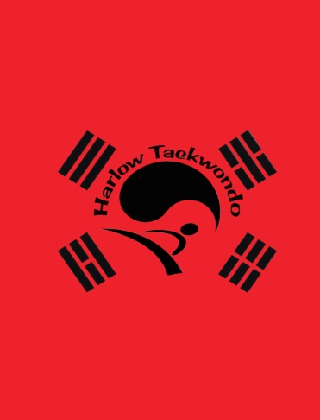
Green Belt Terminology...Won Hyo
Green belt signifies the plants growth as the Tae Kwon Do skills begin to develop.

- When was the TAGB formed? 21st of august 1983
- Why do you pull your hand back to your chest when performing inwards moving knifehand strike in Won Yo? It acts as a reaction force and is also in a ready position to perform block or strike, the arm also protects the ribs.
- What is three step semi free sparring in Korean? Ban jayoo matsoki
- Why do we do three step semi free sparring? Advanced techniques, closer to free sparring, focus, distance, timing play a more important roll.
Stances
- Closed ready stance- moa junbi sogi
- Bending ready stance- guburyo junbi sogi
- Vertical stance- soo jit sogi
Defensive Techniques
- Outer forearm waist block- bakat palmok hori makgi
- Inner forearm circular block- an palmok dollimyo makgi
- Palm inward block- sonbadak anaero makgi
Attacking Techniques
- Side punch- yop jurugi
- Reverse knife hand inward strike- sonkal dung anaera taerigi
- Side piercing kick- yop cha jurugi
- Back kick- dwit chagi
Parts of the Body
- Foot sword- balkal
- Back sole- dwi kumchi
- Ball of the foot- ap kumchi
- Palm- sonbadak
- Reverse knife hand- sonkal dung
Won Hyo is the name of the Silla Dynasty monk who introduced Buddhism to korea in AD 686. 28 MOVES

